fo = open(r"c:\python\student.txt","w")

print("Name of file:",fo.name)

print("Closed or not:",fo.closed)

print("Opening mode:",fo.mode)

fo.close()

print("Closed or not:",fo.closed)

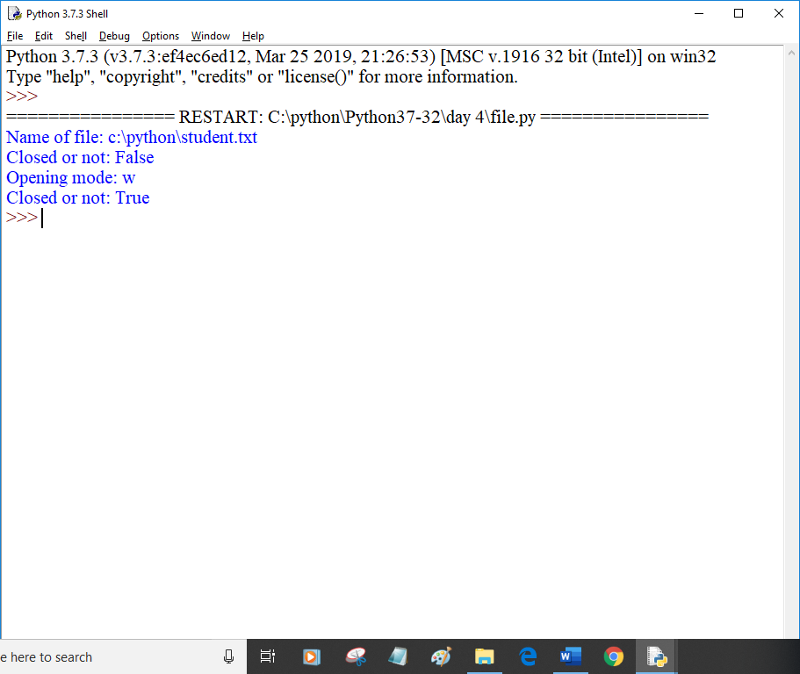

fo = open(r"c:\python\abc.txt","w")

str1 = input("Enter text:")

x = fo.write(str1)

print("No. of bytes written:",x)

fo.write("\nWe are using file handling")

fo.close()

print("work done")

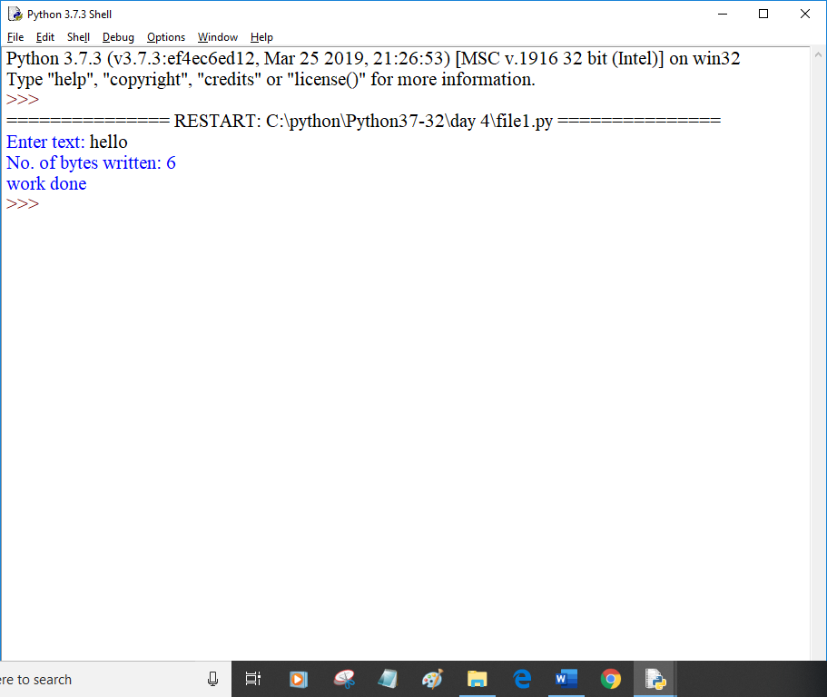

fo = open(r"c:\python\abc.txt","w")

count = 0

while count<5:

str1 = input("Enter text:")#raw_input

fo.write(str1+'\n')

count = count+1

fo.close()

print("work done")

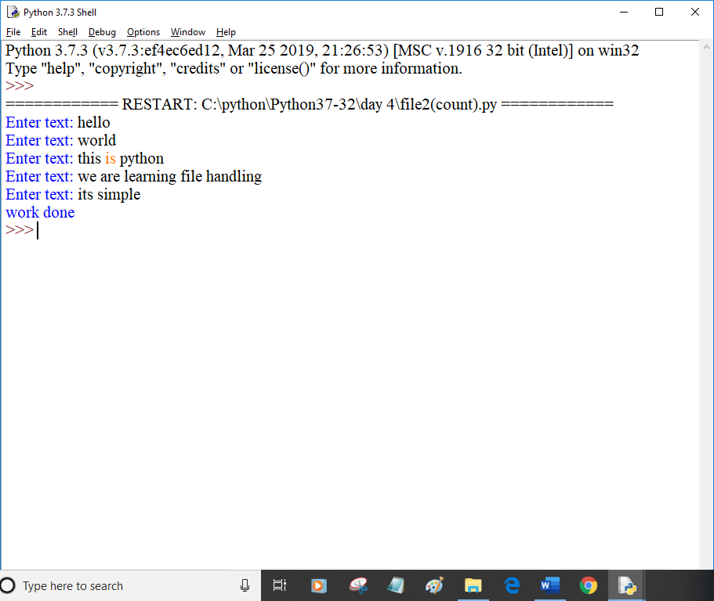

fo = open(r"c:\python\student.txt","a")

while True:

str1 = input("Enter text")

fo.write((str1+'\n'))

#fo.write(r'\n')

choice = input("To exit type x:")

if choice=='x' or choice=='X':

break

else:

continue

fo.close()

print("Work Done")

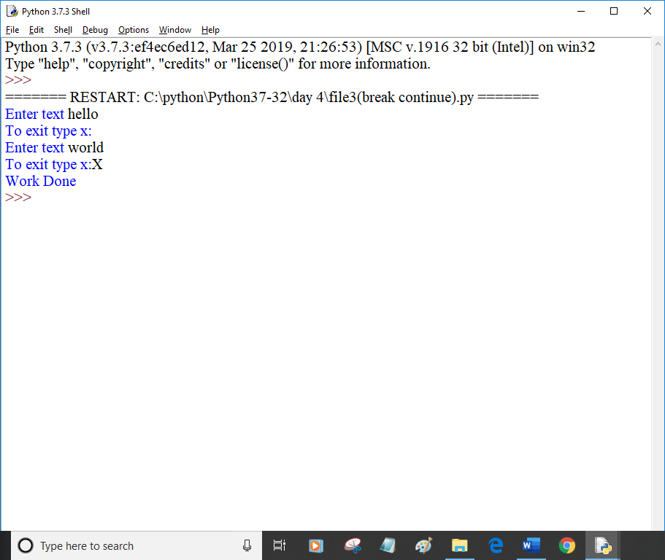

fo = open("c:\python\student.txt","r")

str1 = fo.read()

fo.close()

fo1 = open("c:\python\student1.txt","w")

fo1.write(str1)

fo1.close()

print("Work Done")

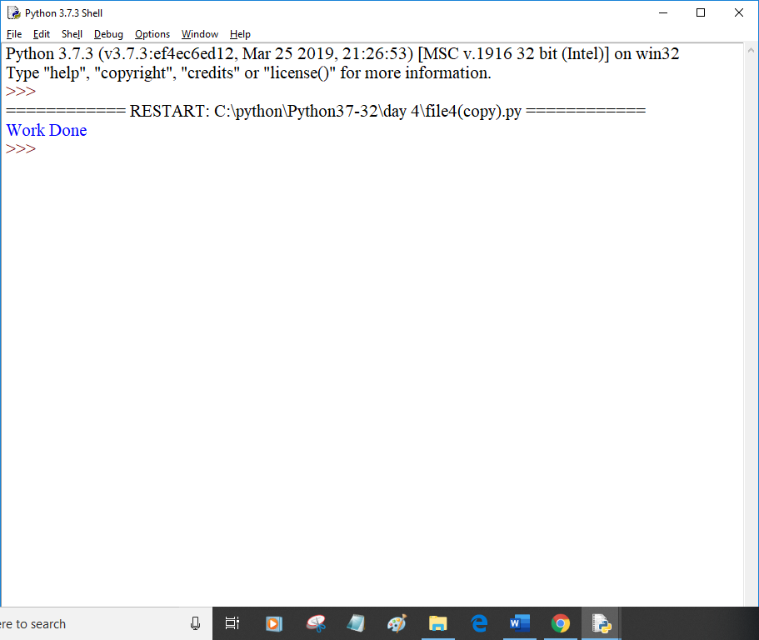

filename = r'student.txt'

for line in open(filename):

str1=line

print("string is:", str1)

words=str1[:-1].split('|')

print(words)

if words[-1][-1]=='\n':

words[-1]=words[-1][:-1]

print(words)

print('-'*30)

#print(str1)

